

Llanwrtyd & District Heritage and Arts Centre Open Art Competition 2026

GENERAL INFORMATION & GUIDELINES

The LDHAC Gallery will be hosting its Art Competition in July 2026 under the theme
‘
‘A WONDERFUL WORLD’
‘BYD RHYFEDDOL’

A panel will assess every entry and select work for the final exhibition. All work selected will be for sale and will be exhibited in the LDHAC Gallery from Thursday 2nd July to Sunday 26th July 2026.
All works will be judged on individual merit and the judges’ decision is final. No correspondence or discussion will be entered into. Work that has been selected for display must remain in the gallery until the close of the exhibition, unless sold.

A panel of judges will award two prizes:
- a cash prize of £500 for the winner (announced at the Private View on Saturday 4th July
- a cash prize of £250 for the runner up (announced at the Private View).
- A Visitors’ Choice prize of £100 will be awarded by public vote (winner to be announced by Monday 10th August 2026)
Prizes sponsored by Charcroft Electronics and Lofftwen Forest Farm
and Col. Tim Van-Rees

Competition Exhibition requirements
- Artists should submit recent work which has been produced within the last three years and falls under the theme – ‘A Wonderful World’
- A maximum of three works may be submitted per applicant.
- All works must be for sale.
- Work that is not for sale cannot be entered into this competition.
- The gallery will retain a commission of 25% on all sales.

The following work will be accepted for competition purposes:
- Paintings, drawings, original prints, art photographs and mixed media works.
- All work must be designed to hang on a wall and framed to gallery standard (no glass clips).
- Maximum image size (excluding Frame) 594mm x 891mm
- Video or sound art will NOT be accepted.
The work submitted must be the original work of the artist named on the registration form.

Cost to submit work
Entry to the competition is free of charge. There will however be a £10 hanging and administration fee for each selected piece – to be paid at the time of delivery of the work to the gallery.

KEY DATES

Applications close | Wednesday 1st April 2026
Selection results available | Saturday 25^{h} April 2026
Delivery of selected work to the gallery | Monday 25th May to Saturday June 27th 2026
Private viewing event & announcement of winners | Saturday 4th July at 7.00pm 2026
Announcement OF Visitors’ Choice winner | Monday 10th August 2026
Exhibition Dates | Thursday 2nd July to Sunday 2nd August
Collection of unsold work | Monday 12th August to Monday 26th August

Application and Submission process

Stage 1:
- Complete the application form.
- Email images of the submitted work to ldhac.art@gmail.com (one image per email). IMAGES MUST BE NO SMALLER THAN 1MB
- Send completed form at the time of submission to LDHAC, Ffos Road, Llanwrtyd Wells, Powys, LD5 4RG. Or email to ldhac.art@gmail.com
The closing date for submission is Wednesday 1st April 2026 at 5pm.
- Please ensure that you have submitted the correct details.
- Please ensure you have read the Terms and Conditions on page 4 and 5.

Stage 2:
- All artists will be notified by email if their work has been selected or not (or by post if no email address.) If you have not heard by Monday 4th May please check your spam folder before contacting the Heritage Centre. All applicants will be contacted.
- Once selected, artists will be sent a contract which has to accompany the work when it is delivered together with a hanging and administration fee of £10. Payment of sold work will be made via bank transfer at the beginning of the following month after close of exhibition
- Digital images of the selected work may be used for promotional purposes – please do not watermark your images. Due care will be taken with use.

Stage 3:
- All selected work should be delivered to the LDHAC, Ffos Road, Llanwrtyd Wells, Powys, LD5 4RG, between the dates listed above – please telephone to confirm delivery arrangements.
- All work must have a label adhered to the back, stating the artist’s name, address, telephone number, email, title of exhibit, medium and selling price.
- Work that has been exhibited but not sold should be collected from the gallery between the dates listed above.

The Llanwrtyd & District Heritage and Arts Centre have the right to cancel if there are not sufficient applications to provide a satisfactory competition and exhibition.

TERMS AND CONDITIONS OF ENTRY
TO BE READ BY ALL APPLICANTS BEFORE SUBMITTING WORK

- Copyright
Copyright remains with the artist, however, by completing the application form and agreeing to the terms and conditions the artist agrees that their work can be used for the promotion of the LDHAC and the exhibition.

- Submissions
All work must be framed or mounted on stretchers and be fitted with D-rings (glass and clip frames not permissible) Work without D-rings will not be displayed. Maximum image size 594mm x 891mm - A1 (excluding frame)
Painting and Drawing
  - Original work and reproductions of paintings and drawings are eligible provided they are one of a signed and numbered limited edition.
- Digital prints are eligible only if it is clear to the selectors that they are original artworks made by the creative use of digital technology. The selectors’ decision on this will be final.

As a guideline for print submissions, prints may be unique (one-off) pieces or they may be made as a signed and numbered, limited edition. All traditional printmaking techniques (e.g. etching, woodcut, litho, screen print etc) are eligible, as are more recent technologies (e.g. digital, photographic etc.) but in every case the print must be of an original creative artwork.
Photography
- Any medium is acceptable, including digital images, photography and photographic processes.
Mixed media
- Mixed media pieces, including textiles are eligible.

- Insurance and Damage to Work
- Exhibitors must make their own arrangements regarding insurance.
- The utmost care will be taken of all works sent in for exhibition, however neither the LDHAC, its staff nor its representatives will be responsible for any loss or damage whilst the works are in their possession.

- Transport Costs
Please note the LDHAC will not cover any costs associated with the transport of works, including the cost of shipping, import or postage. The gallery does not accept liability for damages to works whilst in transit or on the premises.
If work is couriered or posted to the gallery, it can be returned in the same manner if unsold, but the gallery will not bear the cost and arrangements must be made by the artist.

- Sale of Work
- All exhibited works are for sale at a specified price. The gallery cannot accept ‘Price on Application’ (POA).
  - The gallery operates a set commission of 25% on all sales.
- The information you enter on the application form will be used in all promotional/pricing documents. Please ensure this information is correct at the time of submission.
- Artists will be advised of sales, and payment to the artist will be made by bank transfer after the end of the calendar month in which the work is sold.
- The price stated on your submission is the catalogue selling price and this must include the LDHAC’s commission.

- Works Inadmissible
- Works that have not been fitted with D-rings.
- Work that has been copied from images found on the internet, using copyrighted source material.
- Works not labelled correctly.

- Collecting Your Work
- Unsold work can be collected from the LDHAC on the dates noted above.
- If a third party is collecting unsold work on your behalf, please notify the gallery beforehand and ensure they have ID.

If any work submitted has not been collected within six months after the closing date, (31 December 2026) the LDHAC shall be entitled to, without prior notice to the artist, sell or otherwise dispose of such works and to devote the proceeds of such sale or other disposition as it may think fit in its absolute discretion.

PLEASE COMPLETE THE APPLICATION FORM ON PAGES 6 & 7 BELOW AND KEEP A COPY FOR YOUR OWN RECORDS

CLOSING DATE FOR SUBMISSIONS IS WEDNESDAY 1st APRIL 2026

Please direct any Art Competition queries to ldhac2016@gmail.com
(NOT the email for submissions)

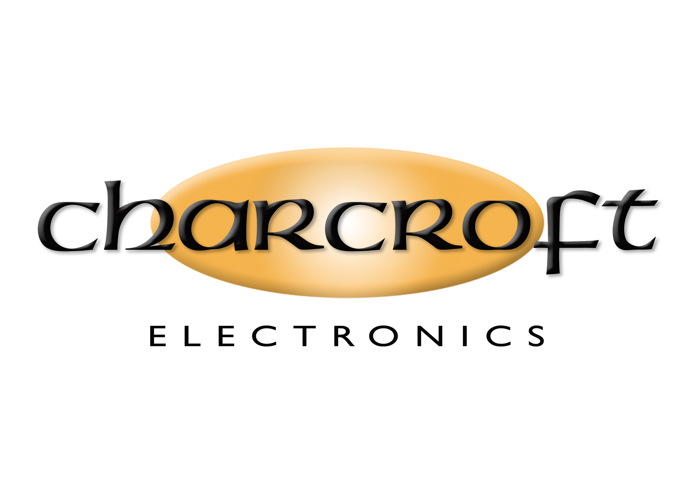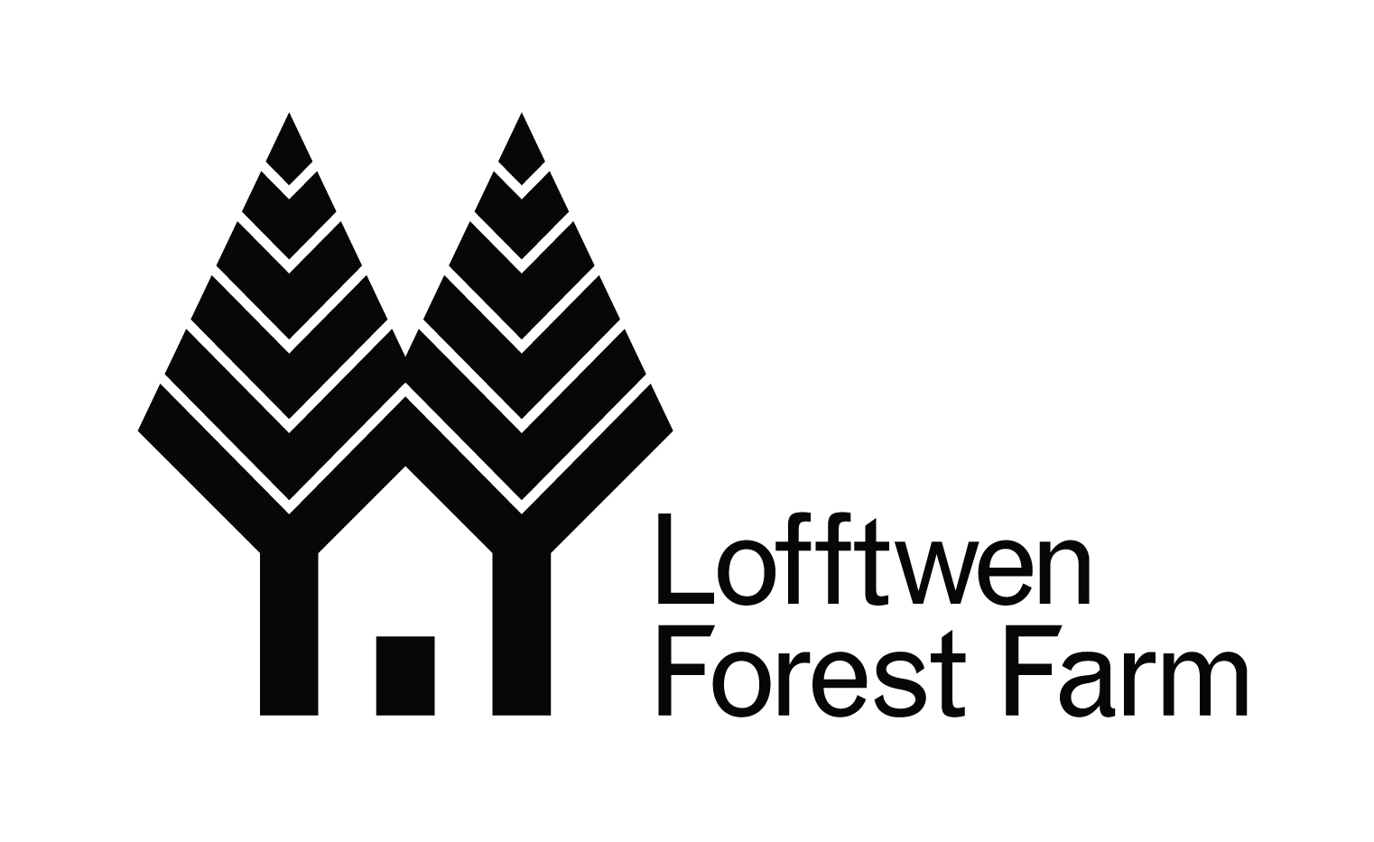

Llanwrtyd & District Heritage and Arts Centre

Ffos Road, Llanwrtyd Wells, Powys, Wales LD5 4RG

Contact Details
Name
Email address
Address

Mobile Telephone Number
Landline Telephone Number
Works
1 | Title
1 | Medium
1 | Size (cm)
1 | Price  including commission
2 | Title
2 | Medium
2 | Size (cm)
2 | Price  Including commission
3 | Title
3 | Medium
3 | Size (cm)
3 | Price  including commission

Artist’s Statement/Biography
(no more than 100 words)

Agreement – Please sign below
I have read and agree to abide by the terms and conditions of entry to the LDHAC Open Art Exhibition, and I will undertake to submit and collect work(s) at the stated times.
I agree to be placed on the LDHAC mailing lists for newsletters and other information, for the duration of the competition in the year of registration. (We will not pass on your details to any third parties.)

Artist’s signature: | For office use:  Received: Selected:  Date notified:
Date: | For office use:  Received: Selected:  Date notified:

